Craig Richards Tuning guide 2023

Mainsheet bridle:
The mainsheet bridal is not your friend. It can burn out winches if incorrectly set and if that does not spoil your race then it has sneaky ways of snagging your mainsheet, which it will always do at the bottom mark when you are in the lead!
I think I had one of the loosest mainsheet bridle setups at the Globals. I will show detail later of what the bridal looks like with each of the rigs, but its not something I adjust. It stays the same for all rigs.
Mine looks like this:
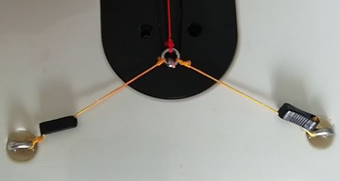
The first snag is probably only on the older boats. The bridle eyes were originally a bit larger and not always screwed all the way into the hull. Because they stood slightly proud, the mainsheet could loop around them and snag. This could be fixed by tacking away if lucky, but often the boat will stall head to wind and it is very difficult to recover from quickly. If you don't realise what has happened and continue to sheet in and hope for the best, the winch is stalled and may overheat etc.
The fix is to screw them in all the way and fill the recess with epoxy glue.
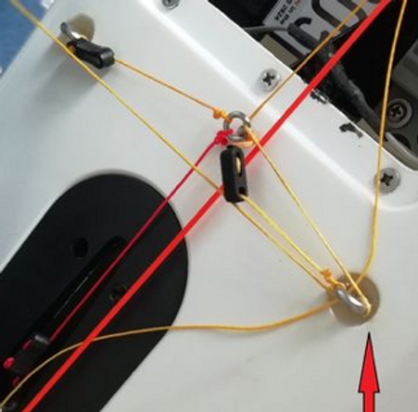
This is about as close as I will ever sheet in. There is never less than about 5mm between the bridle eye and the boom fitting.
The starboard bridle line is slack, so this is as high as you can get the bridle eye off the deck.
There is almost no vertical mainsheet tension so the winch has very little load and fine adjustments to the sheeting angle are possible without affecting the mainsails leech tension.
The port bowsie should be hard against the deck eye, but I mucked with it for demo purposes and have not fixed to my preference yet.
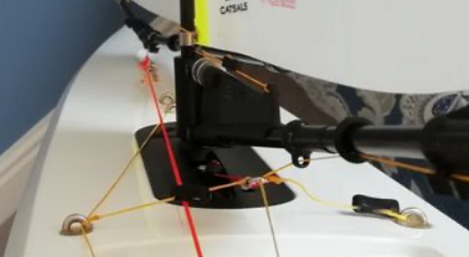
With a straight run for the jib sheet, it can get a bit snagged against the mast. Yes, jib fairlead is glued as well. I'll do a section on each rig, but the further forward you move the jib boom sheeting eye the further the jib will go out on the run. I've set mine so that both the main and jib reach 90 degrees at the same time on the runs

Sheeting:
This is how I run my sheets.
It's not optimum from a friction point of view, but there is a tradeoff between reliability and the jib setting slightly differently on port and starboard tacks.
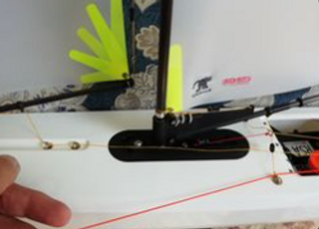
If I only use the front jib sheeting deck eye then the jib boom goes slightly further out on the starboard side. It's a small amount, which is reduced by going through both eyes ...
at least I think it does.

I put the jib sheet through the port bridle deck eye to keep it away from the mast. In light conditions the thin yellow line (0.20mm) gets snagged between the boom gooseneck and the deck.
It's only slightly sticky, but enough to stop the jib going out on the runs occasionally.
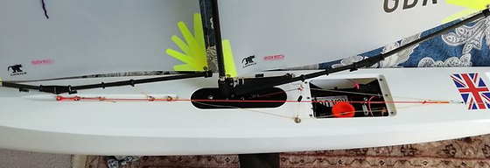
Its not necessary for stronger conditions, but I stick to one way of routing all my sheets just to keep life simple.

The A rig:
I'll be posting some measurements, so just want to show what my masthead crane looks like as some of them sit a bit proud of the plastic mast insert.
I think the standard sail templates have too much luff curve. I have a 'custom' luff curve from Catsails that has about 2mm less mid mast.
I run the top of the sail at the bottom of the silver band and the attachment point to a second hole in the mast crane. I think the top of the sail behaves better with this setup.

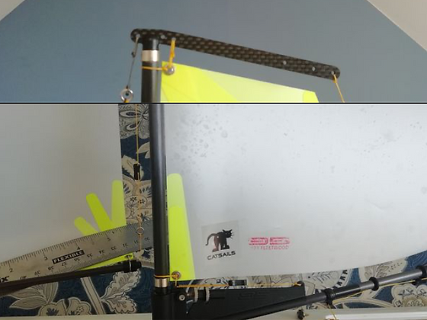
I run the mast gate as far back as possible and never touch it. It stays like this for all rigs.
The DF seems to want as much aft rake as possible. So I rake it as far as it will go.
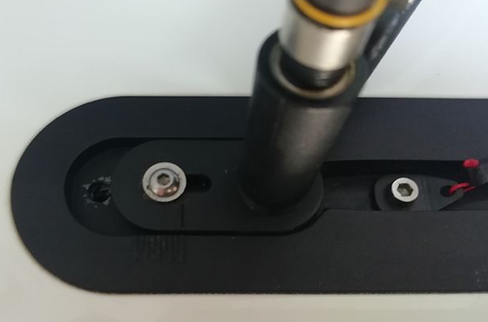
I would rather take luff curve out of the front of the sail than bend the mast further. Too much mast bend means you need more vang on the beat, but this can lead to too tight a mainsail leech on the runs

Mast Rake:
With no Jib Forestay tension I want the mast curve to match the front of the main sail as far as possible.
The curve I settled on was to tighten the backstay until the second attachment point from the bottom was just behind the mast (NB, remember I have about 2mm less luff curve than standard). This was easily repeatable without needing rulers etc.
I then marked the backstay adjustment lines and always adjust straight to this point. I never change the backstay again except at the very top of A rig I might add a mm or two.
The measurement from behind the bow bumper to the front hole in the masthead crane is 1140mm. This may seem further back than the rigging guides, but remember there is no forestay tension at this point.
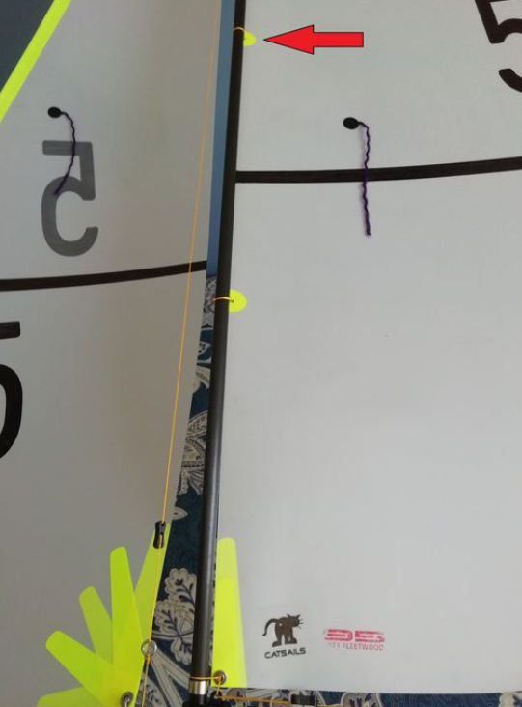
With a flat edge behind the mast, the mast curve is only 3-4mm, which is less than I was expecting.

A Rig forestay tension:
The A rig is the only suite where I change forestay tension. The rest have the forestay as tight as I can get it until I start worrying about breaking the boat or having the mast go out of column.
You never want the forestay to pump or flog upwind, so for each increasing wind condition you go just a bit tighter so that you get a bit of sag, but no pumping. At the very top of A, the tighter the better and do not let it sag.
The sag and a loose jib cunnigham seem to put a bit more fullness into the front of the jib and with very sensitive telltales you can see that the fuller the jib entry the longer the flow seems to stay attached to the leeward side of the jib. This is particularly helpful in very dirty air with lots of wind switches etc.
The forestay length on my boat varies from 1138 to 1132mm from the lightest to strongest conditions. My go to setting when I am unsure turns out to be 1135 just as the rigging guide suggests.
It will also depend on how much your backstay stretches, I use the below on my backstay:
As Per Krabbe has kindly pointed out, dyneema lines are prone to shrinking. I have marks to quickly put the rigs into the boat (last minute change before heat etc), which I do check
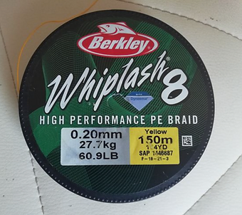
before each regatta, but over a few days the lines may still change length.
I have a fairly good feeling now for what the rig should look like, but it's probably a good idea to check the lengths regularly.

This is how I set up my main sheeting angle on the A rig:
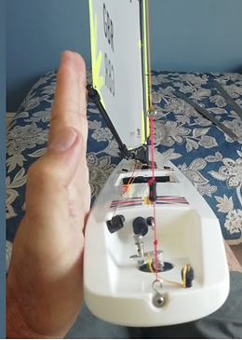
I put the palm of my hand against the aft quarter of the boat and when sighting from astern I have my fingers parallel to the backstay. With my hand in this position the main boom just touches my fingers.
No measurements, no confusion and very easy to repeat.

Yes it's wider than just about every tuning guide suggests, but at this point I am just setting up consistent sheeting angles of the main and jib (to follow in next post)
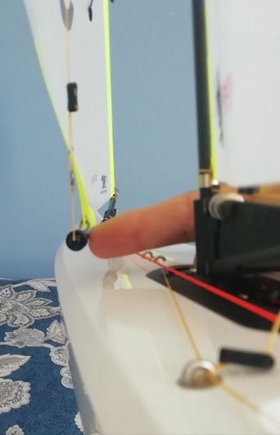
With the main sheeting angle set, the jib is then trimmed such that the hole in back of the jib boom fitting is over the first knuckle on the deck. It's close to 60mm between the middle of the mast and the inner edge of the boom.
In my case its also exactly the width of my three middle fingers.

I do sail with the setting I posted. Here is my go fast mode:
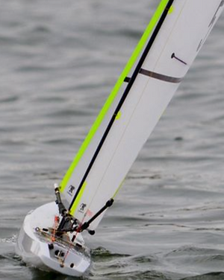
I run 20mm foot depths on the main and jib as a starting point. In this mode I want the boat to run with absolutely neutral helm. It can hunt the breeze slightly, but must never luff up and slow down. I never want to be pulling the bow down with the rudder. I may trim in and and push the bow up. This is absolutely the best VMG mode in the absence of other boats. You will go faster and end up higher than a boat that sails only in pinch mode.
I use the bottom draft strip a lot. I want to see the maximum depth at 50% and a clean straight entry after the mast. If the fullness is further forward I flatten the foot of the mainsail further
If the boat is running with a bit of weather helm as the breeze increases I will first flatten the main off to about 10mm and if that does not work I will change the trim to let the main out slightly further, but leave the jib the same. I will also flatten the jib down to 10mm at the very top end of A, but only after the main is already down to 10mm.
The neutral helm also has the advantage that when I am unsighted and cant see the boat it is still sailing flat out without my input. This is also a big advantage when the boat is too far away to see clearly.
That lower tell tale on the main is a great trim indicator. It should fly at a slight up angle on the weather side of about 20 degrees. In this photo it says I am sailing a fraction lower than optimum and I should push the boat up with the rudder.
The neutral helm has one further huge advantage. As I tack, once I am on the new heading I seldom need to keep on some weather helm until the boat gets its speed up again and starts tracking. The boat also tacks much more cleanly as a result and I stall less when I make a mistake. i.e. its much easier to get the boat going again from a bad tack.
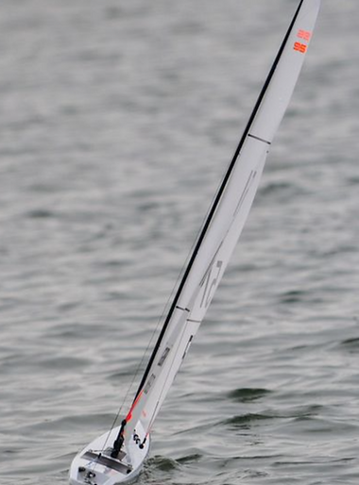
And a great picture of John.
He sheets the main in a bit more than I do, but the jib is still quite wide. This is probably his pinch mode though and if he dropped the main slightly so the jib is over the deck knuckle we would be quite close in setup.
One difference is that the entry angle on the main on Johns boat at the first draft stripe is a bit wider than mine, so he would need to sheet a bit closer. My entry looks a lot flatter, so I can sheet the boom out a bit and still have a similar entry angle. This could be because I have a bit more mast bend coupled with less luff curve. I actively set my mast bend so that the luff at this height moves behind the mast. i.e. the luff sits on the centre line, not to leeward of the mast.
Notice how flat he now runs his main foot depth. I was running 20mm, but John looks to be even flatter.
It's also a great picture for showing the twist in the sails and a perfect example of how the twist in the jib parallels the back of the main.

Active trim:
My high mode has the jib width at 45-50mm, about 1cm - 1,5cm in from my best VMG mode.
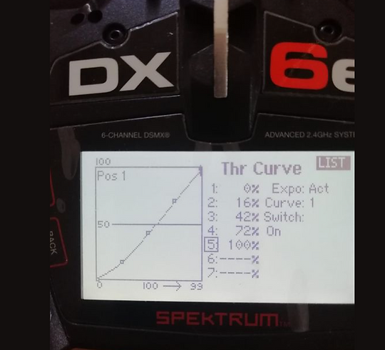
I have the ratchet set for the mainsail trim on my radio. I move the trim/throttle stick on the radio so that it is two ratchet clicks up. This is the radio setting that I want to see my VMG sail setting at. I use the subtrim buttons on my radio to move the sails to that setting.
With the trim all the way in I now want the jib to be at 50mm or perhaps even 45mm in very flat water. Depending on the radio, two clicks may move the trim in more than the desired 1-1.5cm so you would need to change your throttle curve. The radio I used at Fleetwood did not need it, but my newer radio moves the sheet too far and I have set a throttle curve.
If there are boats around me and I need height, I will start with the boat at two clicks out and then once it up at full speed, I start to bleed the boat up as I trim in. Often you can carry a high fast mode for a length of time, but if I hit a bad wave or header and the boat slows then its immediately trim to the two clicks position, get the speed back and then work the boat up again one or two clicks.
If I am in clear air and chasing then I found the boat very fast at two clicks out and did not trim in much
The higher trim mode is also very useful if you get THAT boat below you that is racing only you and the fleet disappears into the distance whilst they try and luff the heck out of you. Your race is still toast, but at least it does give you some time to find a gap to tack away in.
If you do have some space to leeward, then even with the wider trim you may be pleasantly surprised to see that you don't lose height and will roll over them quite quickly.

I'll try and do a bit on twist, but here is a hint that I do not have enough twist in the top of my jib. Camber stripes are your friend.
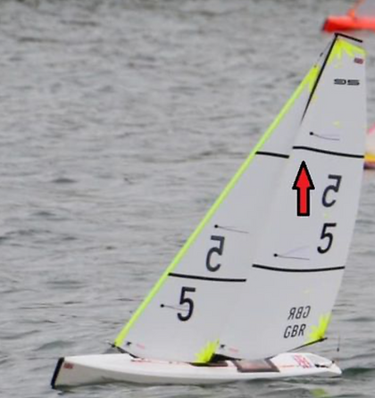
The bottom windward telltale is running at the angle I like, but the top one suggests I have mucked up the trim. It should match the bottom as closely as possible.

Mains twist.
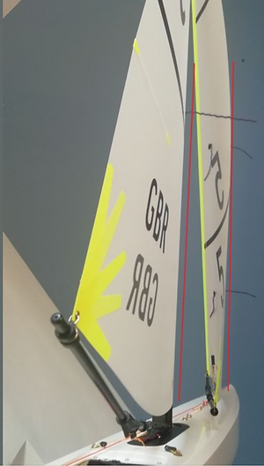
Finicky beast. Half a turn on the vang can make a surprising difference. I can only suggest a starting point and then fiddle with small changes until the boat looks and behaves to your preferences. Looking at the boat from behind when the boat is on the water and using the picture of John's boat as a template would be a good start. Looking down the backstay from behind the boat, I want the main leech to parallel the backstay between the top two battens. It was difficult to take a photo, but fairly obvious in real life

Jib Twist.
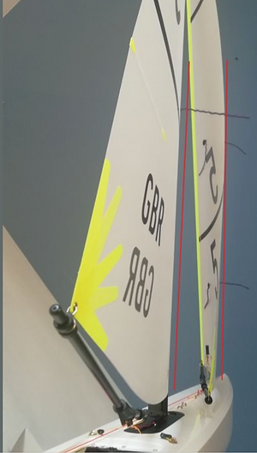
I like the jib leech to parallel the back of the main for as far as possible. The upper third of the jib should also parallel the main entry angle as far as possible. Top of jib and upper third of main should start to luff at the same time as you head up into the wind.

Earlier I posted a near perfect picture of John Tushingham and now I hope he forgives me for posting one a bit more ugly
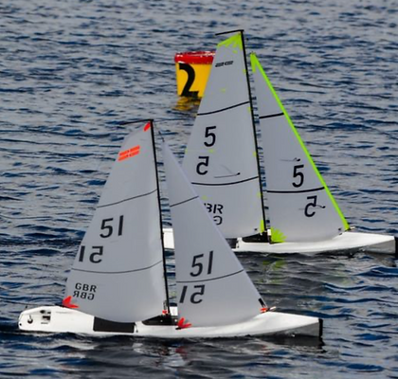
This was taken a month before the Globals and I think I had an edge on boat speed in this race. I never saw his boat look like this in the Globals and want to use this to point out how top sailors like him are prepared to adapt and experiment.
In this photo we have similar rake, but I am running a more bent mast, with flatter sails. A much finer entry for the main as a result, which should result in a cleaner and wider slot between the back of the main and the jib.
The difference in speed was very small, but even a cm or two of extra speed helps get your nose out in a crowded start and makes you look like a better sailor.
Compare this to his globals setup

B-Rig
Quick reminder that these are my settings and opinions and are not the only way to do things.
I was not very fond of the B-rig, but took the opportunity to go out and sail whenever there was enough wind in the evenings.
After a few sessions of just buggering around with silly settings I started to really enjoy these sessions as the B-rig has such brilliant contrast between just sailing and sailing fast and once you found the faster settings the boat itself became increasingly easier to sail.
I went into the first B-rig race at the Globals not knowing if I had got it right as I have had nobody to sail against.
In short it was a very pleasant surprise and I had speed to burn. As the regatta wore on I made a few mistakes (getting off the lee shore etc) and started to second guess myself and changed the setting to trim a bit narrower, which was a mistake in retrospect, but I was not too stessed as I could still hang in for a top 3 in most races.
The fastest boat was probably sail number 121. A bit inconsistent, but when he got it right had a definite edge towards the end of the regatta.
There could be some advantage to the icarex sail material in these conditions, but if anything this boat was sheeting the jib wider than I do when it was flying.
If you set the B-rig up anything like the A, the first thing you will most likely notice is lee helm and the first attempt to fix this would be to pull the main up to the centreline. It does balance the boat, but the groove becomes very narrow and it's hard to keep the boat going fast and tacking can become a bit harder.

What worked for me was:
As much aft rake as possible to take out some of the lee helm. I wanted the flattest entry angle possible with the maximum camber back at 50% in the lower third. So I bent the mast to take out all the luff curve. All 5mm of it.
The tightest forestay possible, just short of breaking the boat. It makes the boat easier to tack and also takes shape out of the jib keeping the entry flatter.
I wanted the widest main I could get away with and to keep things consistent I start with the main boom against the palm of my hand when my fingers are parallel to the backstay as normal. Most of the other boats do sheet a bit closer. Good, I feel I am faster.
With the main boom in this position the jib boom is now over the side of the boat. 65-70mm between the mast and jib boom.
I do have a 'point' mode where the jib may come in to 55-60mm, which could be used off the start line, but once clear I am sheeting out again.
The jib is flat, 10mm-15 mm foot depth. The jib twist is still parallel to the back of the main, but you can twist it off a bit more at the very top of B rig conditions.
The main is flat. I run 15mm, but JohnT is even flatter at 10mm or less. There is a fair amount of twist in the main, which you can get away with as with the luff curve taken out by the bent mast the slot is already very wide.
The more twist you have, the faster the boat, but the limit is when the top third starts to backwind.
I start with the main twist setting as follows. With the main at the VMG setting, sighting up the backstay a line drawn through the bottom two mainsail battens is parallel to the backstay.
Run out of time. Will add a bit more later
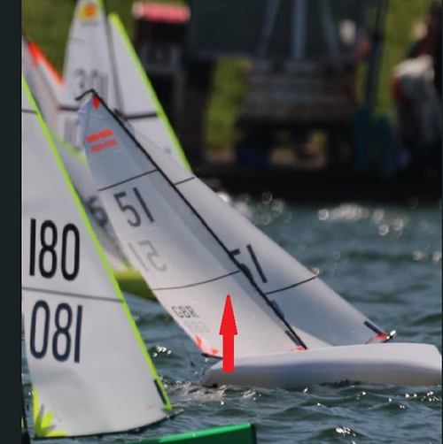
In the meanwhile here is a nice picture of John, over the start line , but a nice example of a fast setup
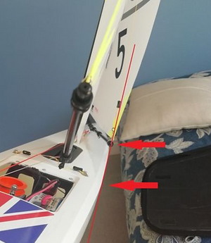

B rig Sheeting Angle: More detail to follow, but its wider than you think. Three fingers will no longer do the trick.

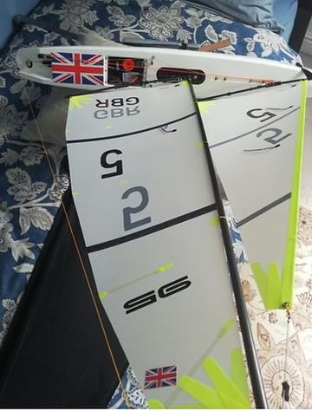

B rig: Backstay and mast: Bend that baby. Luff curve matches back of mast the entire length. Standard or 'stock' luff curve.
Flat sails. Jib down at less than 15mm foot depth. I run 15mm on the main. John T was flatter.

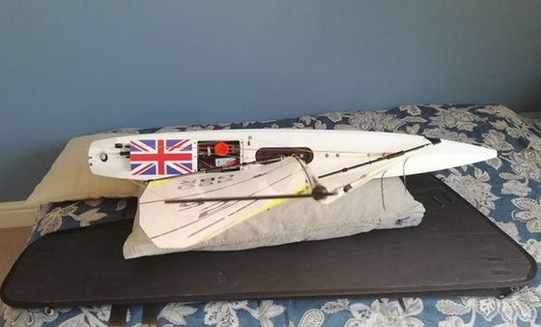
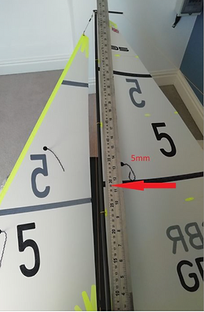
B-rig: More mast curve:

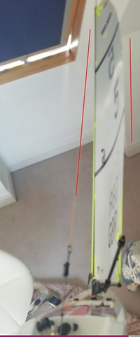

B-Rig Main twist:
Phone camera perspective mucks things up, but a line through the ends of the bottom two battens is parallel to the backstay

